Student worksheet

1.4 Mitosis forms new somatic cells

Pages 10–11

Mitosis

1 Match each term with the correct definition.

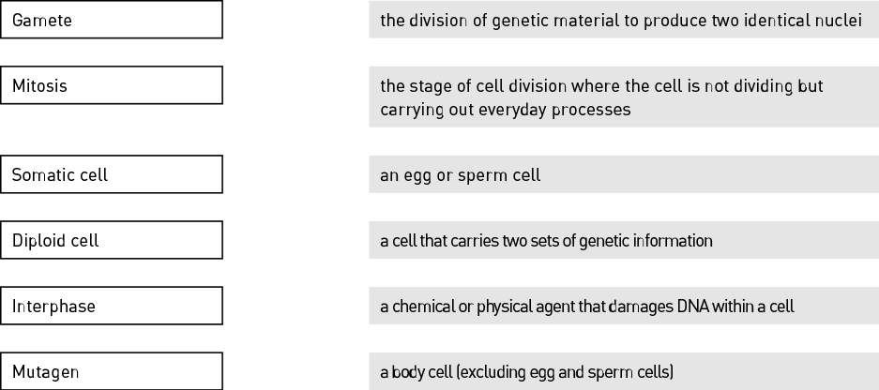

2 Identify the stage of mitosis shown in the following image.

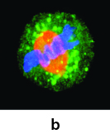

|  |
| --- |
|  |

3 Describe what occurs during this stage of mitosis.

|  |
| --- |
|  |
|  |

4 Why do somatic cells need to undergo mitosis?

|  |
| --- |
|  |
|  |

5 Identify three ways a cell’s DNA can become damaged:

|  |
| --- |
|  |

6 Explain why a cell undergoes apoptosis.

|  |
| --- |
|  |
|  |
|  |
|  |

7 Fill in the blanks.

The processes of and together produce two new, genetically identical daughter cells.

8 Explain why a cancerous cell continues to carry out mitosis rather than being destroyed by apoptosis.

|  |
| --- |
|  |
|  |
|  |

9 Label the stages of mitosis shown in the image below.

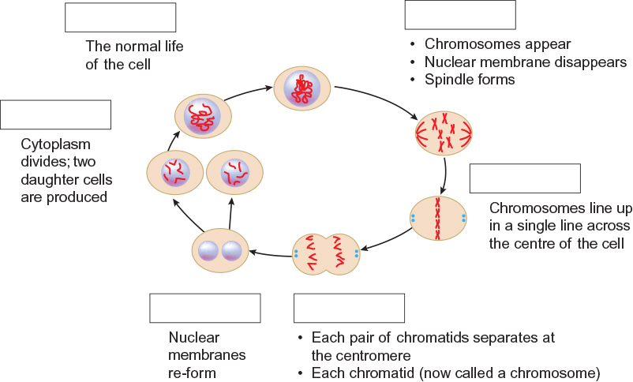

Extend your understanding

10 Identify the cell types that undergo mitosis by writing ‘yes’ or ‘no’ in the table.

|  |  |
| --- | --- |
| Cell type | Mitosis? (yes or no) |
| Bone cell |  |
| Egg cell |  |
| Intestinal cell |  |
| Nerve cell |  |
| Sperm cell |  |

11 Explain why only some of the cells listed in the table above undergo mitosis.

|  |
| --- |
|  |
|  |
|  |